Glass bottles for mineral water, lemonade and wine
The 111 objects listed below have been through a formal process of deaccessioning and disposal that has been approved by the Trustees of Culture Coventry and Coventry City Council. This process has identified material in the Coventry collections that is either a duplicate, or in poor condition, or if it has become not relevant according to our Collection Development Policy.
Accession Number | Object Description | Image
SH.1949.3 | A glass wine or sack bottle dating to the 16th-17th centuries. | 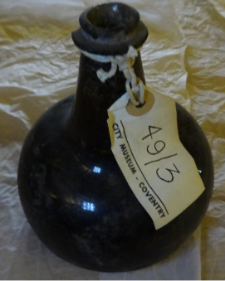
AR.1949.97.1+3 | Early C18 wine bottle.  wine bottle c.1700  Both found at rear of Craven Arms | 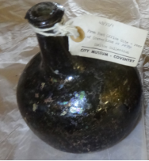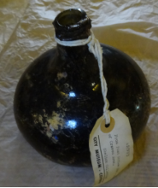
AR.1949.100.1,2,5,7 | Wine/sack bottles from river bed, Benedictine site | 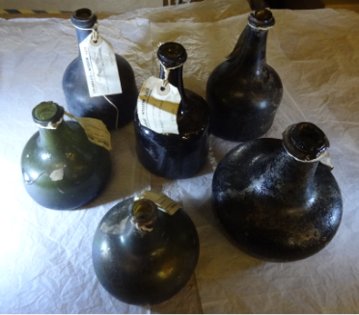
AR.1949.101.2 | An early 18th century wine bottle. Broken | 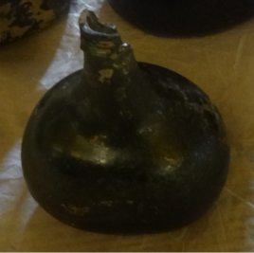
AR.1949.120 | A straight sided wine bottle from the cellar of the Sun Tavern in Spicerstoke, found on October 14th, 1949. The bottle has a broken neck. | 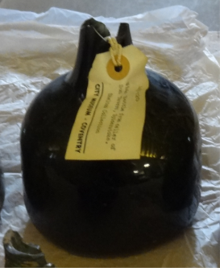
AR.1949.193.dup2 | Neck of glass bottle | 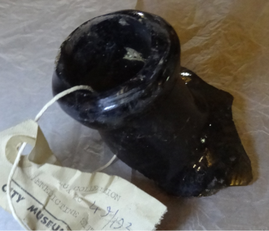
SH.1949.227.174 | A torpedo shaped glass mineral bottle with the inscription 'Andrews & Heath, Coventry'. | 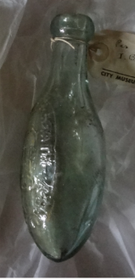
AR.1949.227.175 | A clear glass bottle with a slightly conical outline, decorated with corkscrew moulding.  From Broadgate | 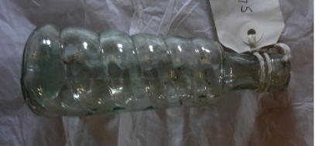
AR.1949.227.? | The neck of a large glass bottle, broken. | 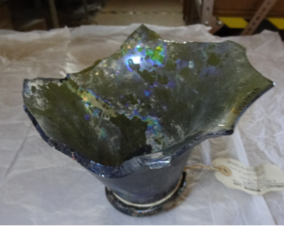
AR.1949.227.263 | The neck of a large glass bottle, broken. From Trinity Street, Coventry | 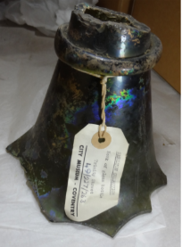
AR.1949.227.264 | early eighteenth century wine bottle from Earl Street | 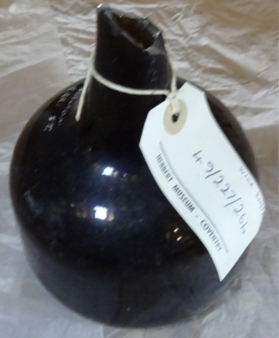
AR.1949.227.265 | early eighteenth century wine bottle. From Woolworth's, Smithford Street. | 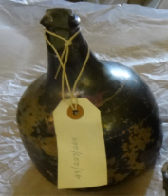
AR.1949.227.266 | eighteenth century sack bottle, neck missing | 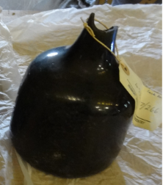
SH.1955.32 | Glass mineral water bottle with glass stopper, inscription in oval on the side and on the bottom. | 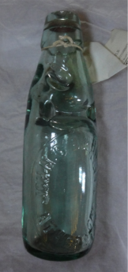
SH.1956.14 | Glass mineral water bottle made by Hinds & Co., Coventry. | 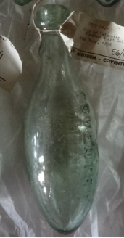
AR.1957.83.2 | Neck of glass bottle from Hay Lane and Priory Row.S | 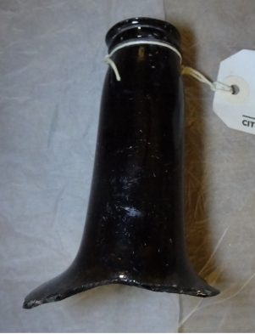
SH.1958.23.22 | Neck of bottle made of green glass. | 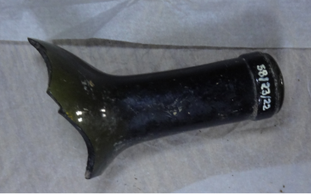
AR.1958.37.1A-B | Two bottles of mineral water, with an oval bottom, made of green glass. Marked 'W. LANT & CO. COVENTRY' with its trade mark. | 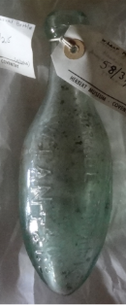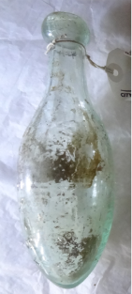
SH.1958.68 | A brown glass bottle for ginger beer. It is marked 'WHITE HORSE. BIRMINGHAM', 'Q2197' and 'C.T.G.'. | 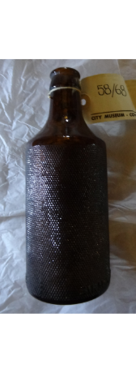
AR.1958.103.2 | Base of wine glass with a stem. | 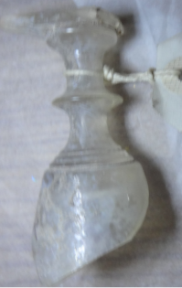
AR.1959.3.1 | Torpedo mineral water bottle by W Lant & Co, Coventry and has the company's trademark. | 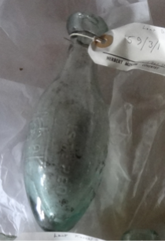
SH.1959.75 | A green glass mineral water bottle with an oval bottom. It is marked with 'LANT & CO. COVENTRY' and has no stopper. It was found in foundation trenches of new clubhouse at Coventry Rugby Football Ground, Coundon Road. | 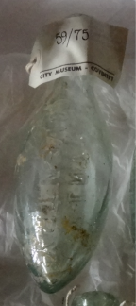
SH.1959.196.1 | Green wine bottle from about 1700. According to Mr Caldecott of Messrs Waters and Company, it was dredged from the River Dart in the 1920s where it had lain after jettisoning by smugglers attacked by gangers.  Register:  dia: 6” H: 5 ¾" | 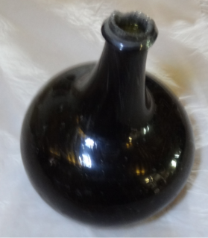
SH.1959.196.2 | A large green sack bottle from the late 17th Century. It has an almost spherical body.  Almost spherical body  Dia: 8” h: 11 ¾" | 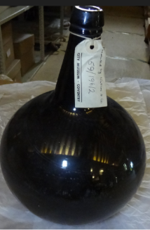
SH.1959.196.3 | Green bottle, repaired  Register:  Very large | 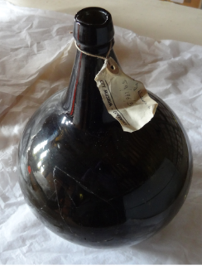
SH.1959.196.wrong | Sack wine bottle | 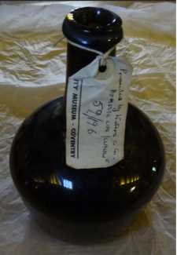
SH.1960.100 | A 'Torpedo' mineral water bottle by 'C. Lant & Co', Coventry. | 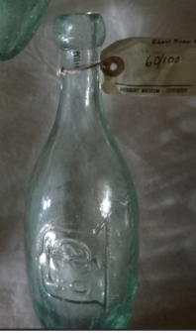
SH.1960.133 | A small "torpedo" lemonade bottle manufactured by the Licensed Trade Supply Society Ltd, Coventry. | 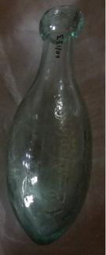
SH.1960.202.1-2 | A "Torpedo" mineral water bottle marked "JOHN WALKER'S HIGHLY CARBONATED COVENTRY SODA WATER".  A glass lemonade bottle with marble stopper marked "BIRMINGHAM SYPHON COMPANY LIMITED", "MERIDEN SI REGISTERED" and on the other side "MERIDEN WELLS", "REDFEARN BROS." and "BOTTLEMAKERS BARNSLEY". | 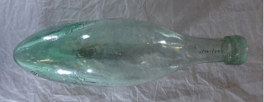  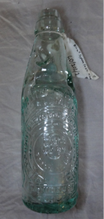
SH.1960.218 | A "torpedo" mineral water bottle marked "H J P Pearson Soda Water Manufacturer Coventry". | 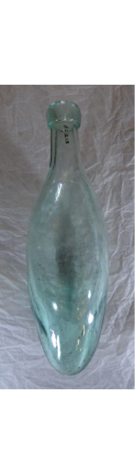
SH.1961.119.2 | Glass torpedo mineral water bottle manufactured by Lant & Company, Coventry. | 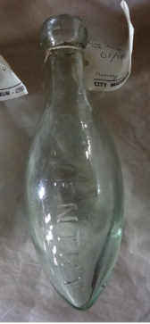
SH.1962.155.1 | A torpedo type lemonade bottle by "The Licensed Trade Supply Society Ltd." in Coventry. It has the usual trademark of lion dancing on waves within a crescent. | 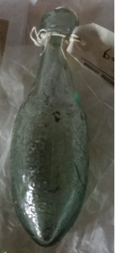
SH.1962.186 | "D. Lyle & Sons" Maidstone. mineral water bottle Its registered trademark is a cross on shield with cross crosslet in each quarter and a hand holding dagger above. | 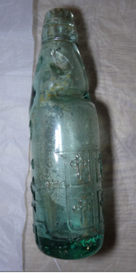
SH.1964.96 | Marble stopper mineral water bottle made for the Coventry Mineral Water Company with a bicycle trademark. | 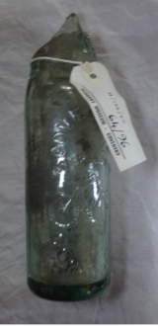
SH.1964.98 | Mineral water bottle made of green glass with a glass stopper as well. It says "THE PROPERTY OF R. WHITE LONDON NO DEPOSIT CHARGED". | 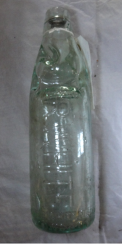
SH.1964.99 | Marble stopper mineral water bottle saying ' Coventry Coffee Tavern'. Its top has broken off. It was found at Kenilworth Road and Kenpas Highway Junction during widening operations in 1958-1959. | 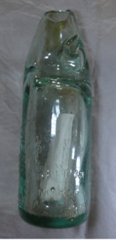
SH.1965.197 | Torpedo shaped mineral water bottle by C. Lant & Co. Coventry with its registered trade mark. | 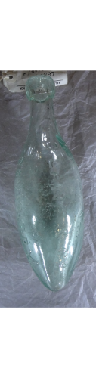
AR.1965.270.1 | Torpedo shaped glass mineral water bottle with inscription "Lant & Co. Coventry". It was excavated during 1965 by the Archaeological Department mainly at the Cathedral site. Relates to CBP65 | 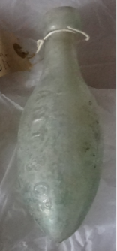
SH.1966.9.22+25 | A glass bottle with metal and glass sealing attachment intact. It has "J. Joce, Bideford" inscribed on its stopper and "Patent. The XL. D Rylands, Barnsley" on the bottle.  Torpedo shaped glass mineral water bottle with inscription "Coventry registered. Lant & Co." and its shield trademark. | 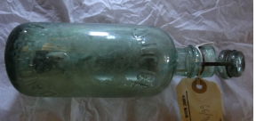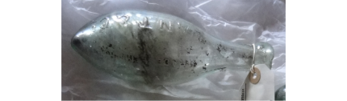
SH.1967.125.2 | A small torpedo-shaped mineral water bottle. 'W. Lant & Co. Coventry Registered Trade Mark.' | 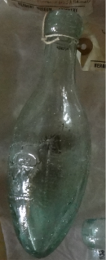
SH.1967.166 | Torpedo Mineral Water Bottle. 'Marriott & Co., Limited, Foleshill Coventry'. | 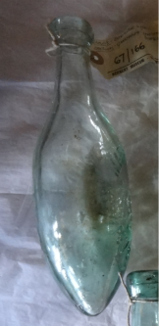
SH.1968.77.2-3 | mineral water bottles with marble stopper, Leamington Spa Mineral Water Company and Leamington Spa Aerated Waters Co. Ltd.  From an early 20th Century rubbish tip at Radford Road, Leamington. | 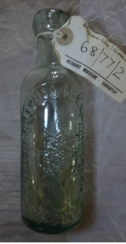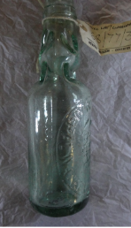
SH.1969.75.1, 3, 4, 5, 7, 8, 10, 11, 12, 14, 15, 16, 17, 18 | 1. green glass wine bottle - "Johnson & Mason", wine merchants, Coventry.  3. clear glass bottle - "J.D. Johnson & Co.", Bottlers, Bedworth.  4. clear glass bottle with top, "R. White".  5. glass mineral water bottle with cap, "John W. Holt", Mineral Water Mfgs (bottler).  7. green glass bottle- "Cave's Brewery". Possibly of Wolston, Warwickshire  8. green glass bottle - "Chas. Southam, Coventry".  10. clear glass bottle - "Kinmond & Co., Leamington".  11. "Phillips & Marriott Ltd.", brewers, Coventry.  (marked x.1288)  12. clear glass bottle- "Mayo & Rugg Ltd., Earlsdon, Coventry.  14. clear glass bottle- "John Holt", Mineral Water Mfgs (bottler).  15. Torpedo mineral water bottle. 'G. Loveitts, Coventry, Soda Water'.  16. clear glass bottle - "L. Chapman, Zenelophon, Coventry."  17. clear glass bottle - "Kinmond & Co., Leamington".  18. clear glass mineral water bottle- "D. Pettifors & Sons, Ansty" | 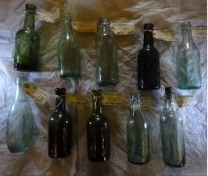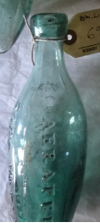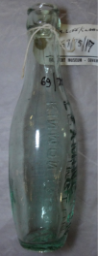  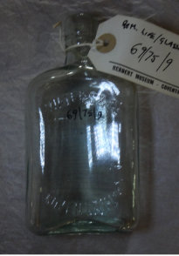  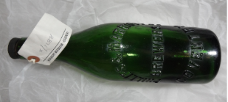  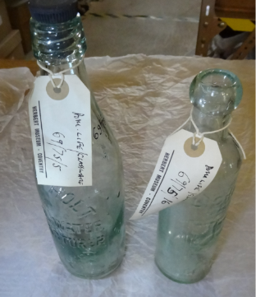  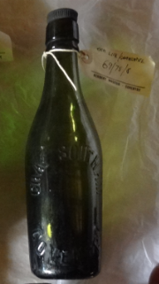
SH.1978.327 | Torpedo lemonade bottle made by Lant & Co. in Coventry. | 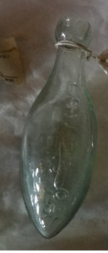
SH.1982.36 | A bottle - Charles Southam of Coventry. | 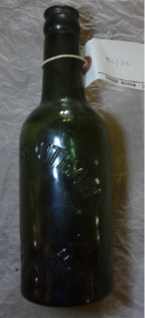
SH.1982.61.1.4  SH.1982.61.1.5-11 (6)  SH.1982.61.2.1  SH.1982.61.2.15-16  SH.1982.61.2.2-4 | - Plain bottle  - Licensed trade supply society Coventry. Cod  - Plain bottle  - Manchester: Barratt&co  - A Grubb (or scrubbs)  - Lant&Co, Coventry  - Lant&Co, Coventry Codd shape  - bottle for Mason's Extract of Herbs for Botanical Beer.  Nottingham  - Lucas and Co, Leamington. Glass bottle, green  - Lipton Ltd London and Ceylon, clear  - A brown glazed ceramic bottle.  - A blue glass bottle  - A glass bottle "Lea & Perrins" | 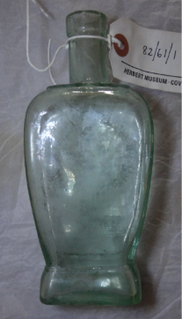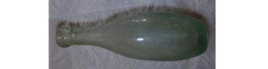  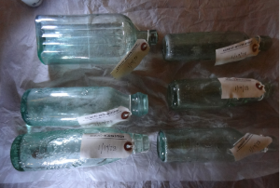  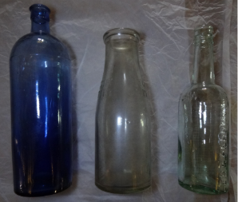  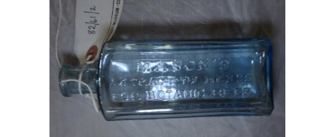
SH.1990.68 | A soft drink bottle: Torpedo Mineral Water Bottle, used 1840 onwards. The bottle was first produced in 1814 and became popular around 1840, made until 1914. Found inside wall of cottage. PLAIN | 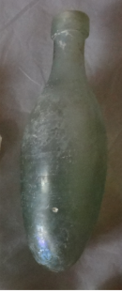
SH.1990.85.6 | A blue stopper - Holbrook & Co. Part of a collection of bottles from Stoke Heath tip, most disposed of 1988. | 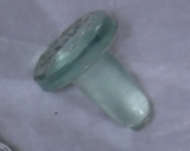
SH.1992.273 | Glass beer bottle, Phillips and Marriott | 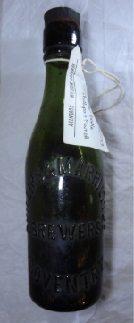
SH.1997.100.1-3 | Two R. White bottles with screw top lids  The Bath Row Bottling Co Ltd bottle with internal screw top lid  All found by donor on his allotment at Hearsall Common. | 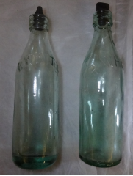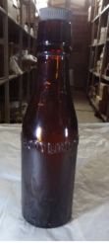
SH.2003.14 | This is a glass (torpedo) egg shaped soda water bottle. It is affiliated with W. Lant soda water manufacturer, Coventry. | 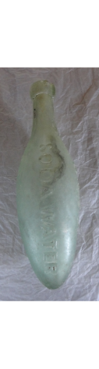
SH.X.1287 | 2 Green bottles -"Mitchell & Butlers Ltd" (w/tops) | 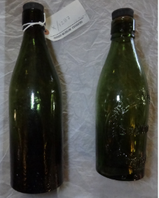
SH.X.1289 | Mayo and Rugg glass bottle | 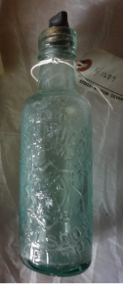
SH.X.1290 | Brown/green glass bottle -"SJ Bishop" w/cap. Ryde, Isle of Wight | 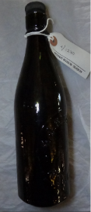
SH.X.1291 | Green glass bottle -"Marstons Ltd" w/cap Burton on Trent | 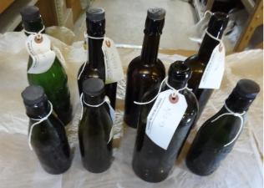
SH.X.1292 | Green glass bottle -"CEO Young" w/cap Coventry | 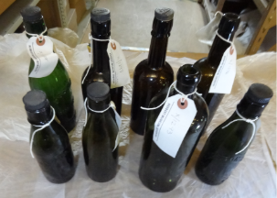
SH.X.1293 | Green glass bottle | 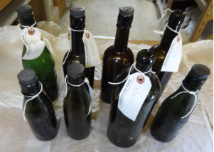
SH.X.1295 | Green glass bottle (w/cap) | 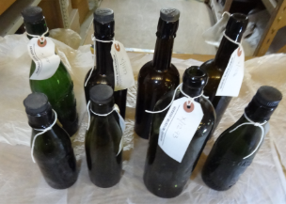
SH.X.1296 | Green/brown glass bottle | 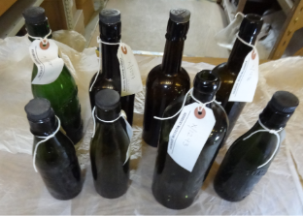
SH.X.1297 | Dark Green glass bottles -"A" on cap | 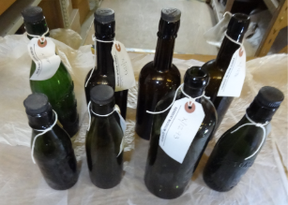
SH.X.1304 | clear glass beer bottle.- "Phillips & Marriott", Coventry. Only one has a label | 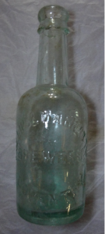
SH.X.1306 | clear glass bottle.- "A. Warner", Coventry | 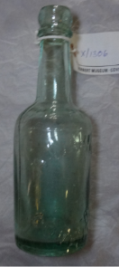
SH.X.1307 | clear glass bottle.- "T. Owen" Sydenham Palace, Coventry. | 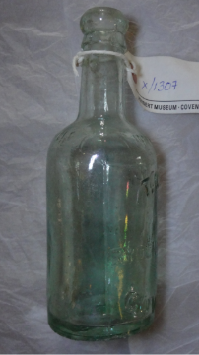
SH.X.1348 | Clear glass bottle- "A. Warner", Coventry | 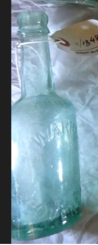
SH.X.1349 | Clear glass bottle- "Imperial Half Pint" | 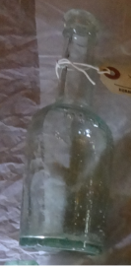
SH.X.1350 | Clear glass marble stopper bottle- "Hinds & Co.", Coventry | 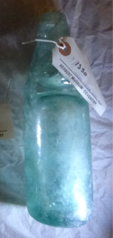
SH.X.1351 | Brown glass panoptican bottle- "Fairchild bros. & Foster" | 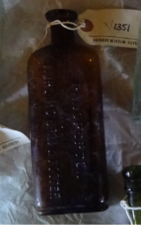
SH.X.1352 | Clear glass bottle- "A. Warner" | 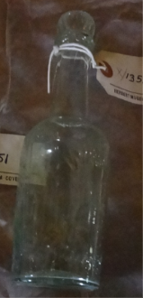
SH.X.1353 | Green glass bottle- "Dowdeswell & Spencer" | 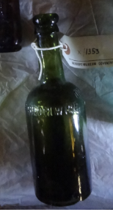
SH.X.1398 | Green glass bottle 'R White' with screw top lid | 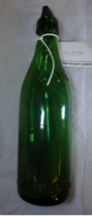
SH.X.1470 | A green bottle 'CS & Co Ltd' on the bottom. | 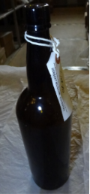
SH.X.1648  (H/31/73) | Commemorative mug. Has views of Coventry, Lady Godiva and Peeping Tom. Broken | 