Miscellaneous items
The 61 objects listed below have been through a formal process of deaccessioning and disposal that has been approved by the Trustees of Culture Coventry and Coventry City Council. This process has identified material in the Coventry collections that is either a duplicate, or is in poor condition, or if it has become not relevant according to our Collection Development Policy.
SH.X.23.2 | Stained glass window | 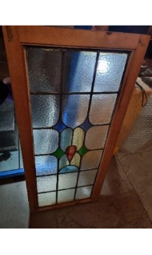
SH.X.25 | Stained glass with green painted wood | 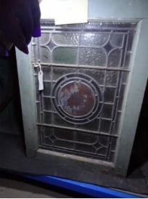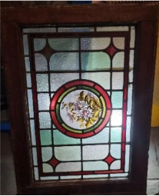  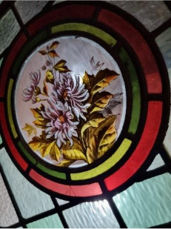
SH.1949.20.1 | Large wooden box relating to Coventry Bakers’ Company. A plain wooden box with a hinged lid and three boxes. | 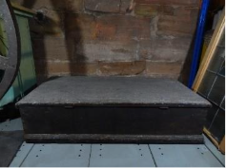
SH.X.1654 | Wheel for unknown purpose  Poor condition | 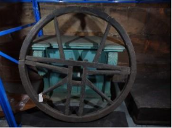
SH.X.19 | Cupboard  According to label it is from St Mary’s Guildhall, however no other corroborating information has been found. Donor is listed but no evidence that this item has been accessioned. | 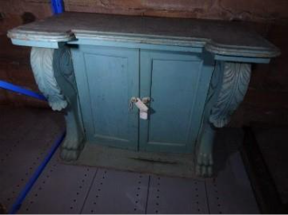
SH.X.50  H/43/75 | Bedroom chair, blue wicker.  Item daybooked but not accessioned. | 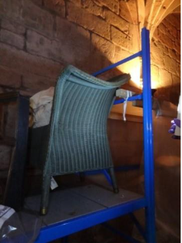
SH.X.51  H/38/75 | Chest of drawers with writing slope  Item daybooked but not accessioned. | 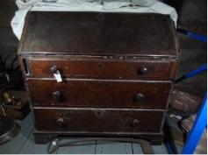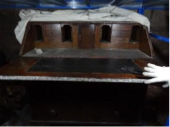
SH.X.6 | Bench seat | 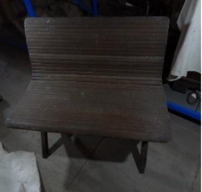
No number | Small spinning wheel  Very poor condition | 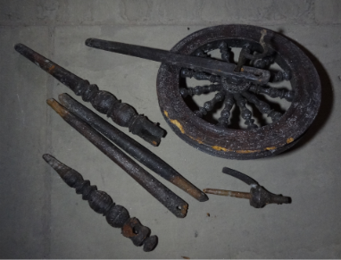
No number | Cardboard plaque:  Deputy Captain Armishaw 1889 destroyed by fire October 7 1889 | 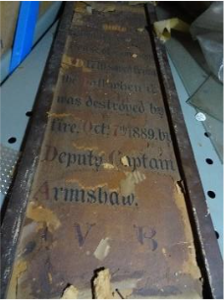
SH.1991.202 | Pick-up tongs used by a blacksmith. | 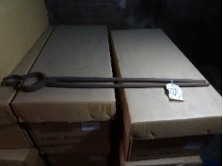
SH.1992.34 | An upper swage used by a blacksmith. | 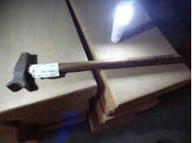
SH.1992.33 | An upper swage used by a blacksmith. | 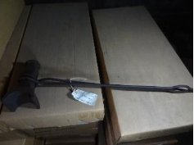
SH.1992.132 | A bottom or lower swage used by a blacksmith. | 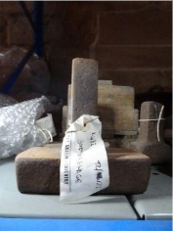
SH.1975.137 | A triptych mirror in plastic bag.  The centre piece is six-sided and the two side mirrors are five-sided. The two side mirrors are hinged to fold, the central mirror swings on its stand. They have a gilded wood surround. | 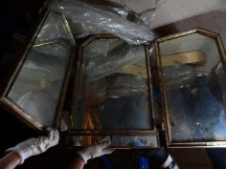
SH.1981.24 | A doll's pram, found in the donor's loft. 1930s.  Poor condition | 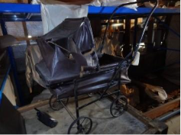
SH.1988.137 | Leather Gladstone bag with initials JAW  Poor condition | 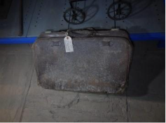
SH.1971.15 | Set of wooden poles with hooks at the end | 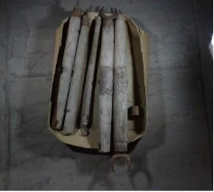
SH.X.1515 – | Clock ringing mechanism and wooden section (stand?) | 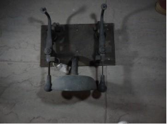  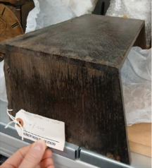
SH.X.439 | Wooden basket, truck or trug | 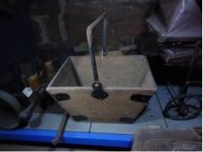
SH.X.789.1-2 | Unidentified wooden objects with no provenance and no known link to Coventry | 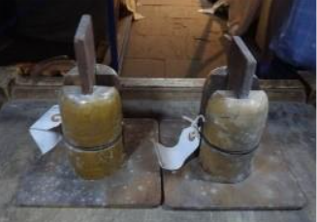
SH.1991.190 | Branding iron made by D.E. Collins and Co, a wine merchant in Coventry.  Poor condition | 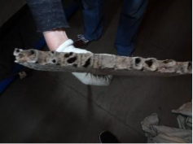
SH.1992.17 | Drill handle | No photo
SH Dup:185  H/103/75 | Linoleum  Piece of linoleum in red, brown, green and black, on sackcloth backing.  Very poor condition | 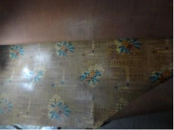
SH.1958.63.1 | A low wooden chair  According to the donor, the chair was used in the weaving shop by women when they fed the chutes of looms.  Harlett Weaving Shop | 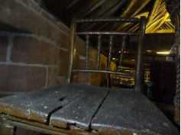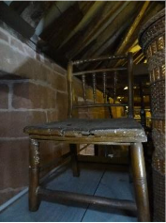
SH.1965.233.2 | Carved chair painted in black and decorated with floral designs of gold. It is upholstered with silk embroidered in multi-coloured flowers and leaves. It was worked by donor's great grandmother in about 1800.  Silk in poor condition | 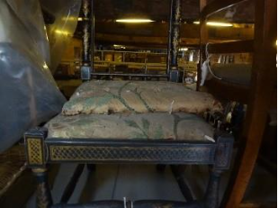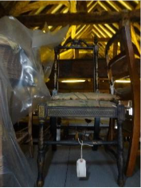
SH.1976.140 | Wicker chair from house in Coventry | 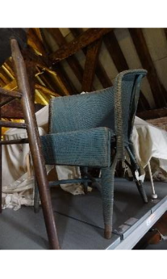
SH.2004.62 | school chair from St Lawrence CoE school | 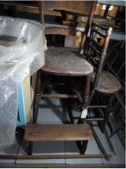
SH.1993.56.2 | A wardrobe bought by the donor's parents in Swindon before moving to Coventry in 1953.  A veneered brown wardrobe with central door and two flanks. Curved ‘Art Deco’ type features on door, sides and legs. Shelves and hangers within. | 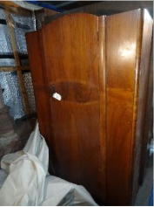  This photo is of SH.1993.56.3, which is the same design as SH.1993.56.2
SH.X.1 | Large double desk with pedestals either side  Poor condition | 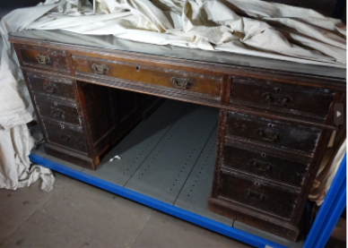
SH.X.42 | Corner cupboard  Poor condition | 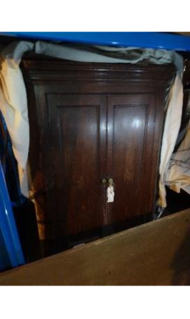
No number | The Holy Bible  Greenaway family | 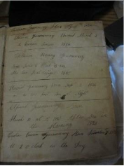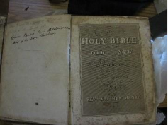
No number | The Holy Bible  Cumberlidge Family | 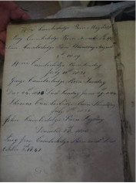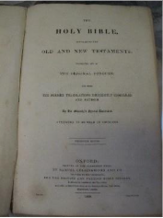
No number | The Holy Bible  Clark family | 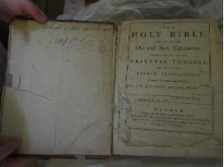
SH.1967.101.1-37 | Stamp albums with individual stamps, envelopes and first day editions  New Zealand: 2 volumes (dates 1855-1966)  Czechoslovakia: 8 volumes (dates 1918-1966)  Russia: 9 volumes (dates 1866-1964)  Hungary: 4 volumes (dates 1871-1964)  Poland: 14 volumes (dates 1918-1938, 1940-1949, 1950-1965) | 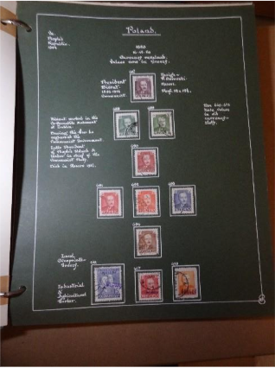
SH.X.963.1-4 | Display (?) stands, possibly used for clothing in a shop | 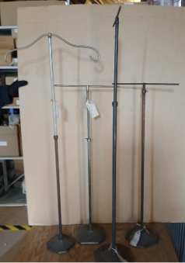
SH.X.272 | Carved wooden box, possibly a bible box | 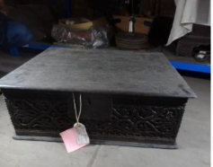  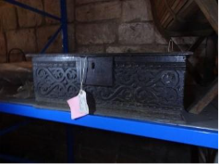
No number  Learning handling collection | 2 b/w postcards showing Joseph Goebbels and Hitler meeting Chamberlain | No photo
L.2008.122  Learning handling collection | Book, ‘Sleepy Time Tales’ | No photo

