Stoneware bottles and jugs
The 8 objects listed below have been through a formal process of deaccessioning and disposal that has been approved by the Trustees of Culture Coventry and Coventry City Council. This process has identified material in the Coventry collections that is either a duplicate, or in poor condition, or if it has become not relevant according to our Collection Development Policy.
Accession Number | Object Description | Image
AR.1949.190.137 | A rim from a stoneware jug of hard grey fabric  Benedictine Priory | 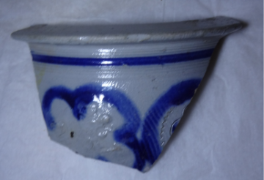
SH.1949.227.334 | A stoneware inkpot./ink bottle | 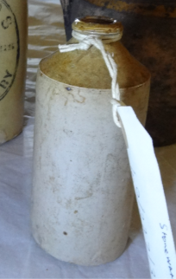
SH.1949.227.336 | A stoneware aerated mineral water bottle stamped with 'Hinds, Coventry' | 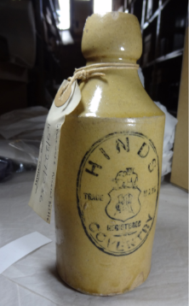
SH.1952.9.1-2 | Two 1-gallon stoneware bottles marked J. Tanser & Co., 6 Cromwell Street, Coventry. | 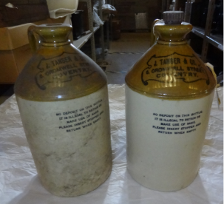
SH.1952.10 | A 1-gallon stoneware bottle marked 'To be returned to Richmond's Botanic Brewers, Holbrooks, Coventry. | 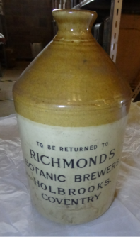
SH.1976.32.1 | Stoneware bottle with screw stopper and is marked "No deposit on this bottle. It is illegal to retain or make use of some. Please insert stopper and return when empty". The bottle is made by J Tanser and Co. at Cromwell Street in Coventry. | 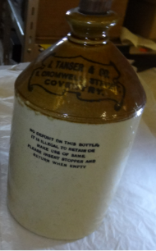
SH.X.1279 | Ansell's brewery jug  Birmingham | 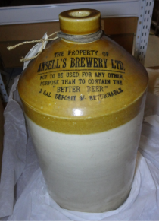

Contact Therese Clews, Collection Officer, museumcollections@cvlife.co.uk
Herbert Art Gallery and Museum, Jordan Well, Coventry, CV1 5QP

