The following weapons are available from the Royal Navy Submarine Museum.
Each weapon has been certified Free From Explosives and a certificate will be provided.
The acquirer is to cover the cost of transport.
Due to their condition, they would be ideal for restoration projects.
RNSM 2001/1743/1 | Mk 8 Torpedo  diameter= 21ins  length= 21ft  weight= 1 1/4tons | 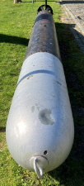  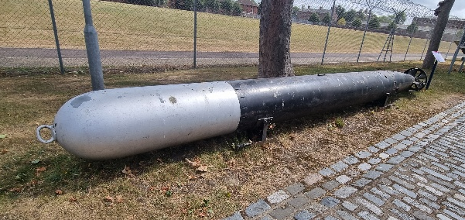 | Condition - The tail end of the torpedo has significant corrosion, this has penetrated through the metal surface leaving sharp holes in the lower half of the tail of the torpedo.  The paint scheme is not original.
RNSM 2001/1736/1 | Mine (empty)  Height – 140cm approx. | 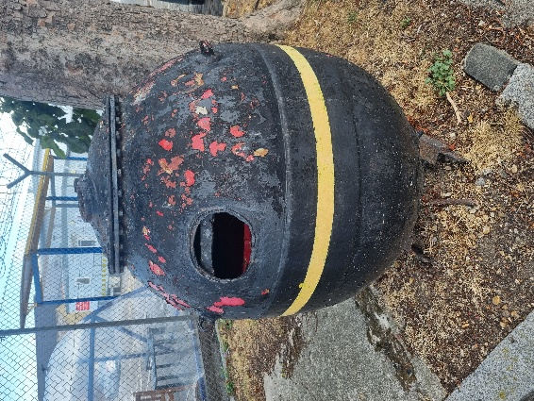 | Condition - The paint is wearing, showing the red primer below.  There is a hole on the front where a sign is missing.
ODF 3967 | Tigerfish torpedo | 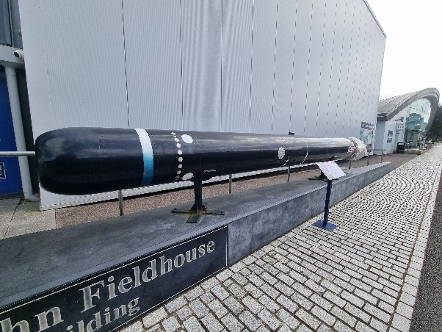 | Condition – the main body of the torpedo is in good stable condition, although the markings/decals are worn. The propeller blades are sharp and are currently covered.

Please contact Alexandra Geary, Curator (Artefacts) to register your interest.
alexandra.geary@nmrn.org.uk

